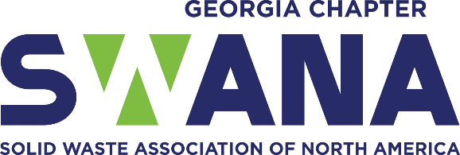
Idea Agenda for Waste & Recycling Workers Week
June 15-20, 2026
Monday, June 15
- Send press release to local media.
- Post Elevate Solid Waste Worker yard signs or banner at the entrance to all solid waste facilities in the community or if funds allow, in all the yards of sanitation/solid waste employees. See sign below from 2021 in Athens-Clarke County.
- Post information on social media using #ElevateSW2026.
- Invite elected officials and/or county leaders to ride-along or shadow sanitation/solid waste staff during this week. See invitation from 2022 below from Athens-Clarke County.
- Provide a box lunch to sanitation/solid waste staff. IDEA: secure a sponsor ahead of time (local restaurant, consultant, business owner, interested resident, local church, truck/equipment manufacturer vendor, waste equipment salesperson).
Tuesday, June 16
- Provide a cookie and/or snacks to sanitation/solid waste staff with the Thank You card from SWANA-Georgia Chapter (in toolkit). Don’t have a local baker? Provide a bag of snacks (chips, granola bar, candy, nuts, fruit) and a drink to the workers.
- Put ad in the local newspaper or other print media with the picture of all or one of the sanitation/solid waste employees in your community to Elevate them.
- Update social media feed using #ElevateSW2026.
Wednesday, June 17
- Provide a promotional item to sanitation/solid waste staff (water bottles, gloves, hats, socks, backpacks, dry bags, etc. ).
- Have a local radio station interview a l sanitation/solid waste employee so they can explain their job and Elevate: History.Individual.Profession.
- Have sanitation/solid waste worker do a virtual storytime for children. Prerecord a worker reading one of the following books and release on this day.
  - Recommended books:
    - Marvelous Cornelius: Hurricane Katrina and the Spirit of New Orleans By Phil Bildner
    - Smash! Mash! Crash! There Goes the Trash! By Barbara Odanaka
    - I Stink! By Kate and Jim Mcmullan
- Update social media feed using #ElevateSW2026. Use our social media frame in the toolkit to Elevate your staff.
Thursday, June 18
- Collect information about sanitation/solid waste staff and create Solid Waste Cards (like baseball cards or business cards but better) to Elevate the profession. See sample Staff Information Sheet in toolkit. Distribute as necessary and fun!
- Encourage the residents in your municipality/community to create signs of appreciation and display them during this week for sanitation/solid waste workers. See examples below.
- Update social media feed using #ElevateSW2026.
Friday, June 19
- Provide a high visibility shirt to each sanitation/solid waste worker to wear as a remembrance of the week.
- Start a podcast to Elevate the stories of Sanitation/Solid Waste Workers.
- Announce Sanitation/Solid Waste Worker of the Week, Quarter, or Year to Elevate the Individual.
- Recognize sanitation/solid waste worker that does/have the following (Solid Waste Superlatives):
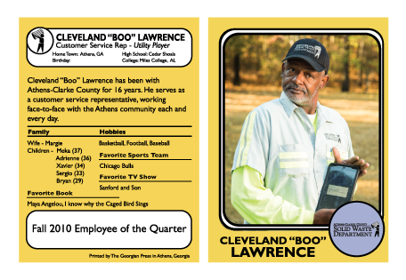
  - Largest Route
Athens-Clarke County Staff Cards
  - Most Tonnage on route
  - Most Compliments
  - Best Safety Record
  - Cleanest Truck
  - Best Attendance
  - Cleanest Shirt/Dirtiest Shirt at end of route
  - Other ideas?
- Organize a Touch-A-Truck event that showcases sanitation/solid waste workers. Host at the landfill to make it even more inclusive to all waste and recycling workers. Elevate the Profession.
- Update social media feed using #ElevateSW2026.
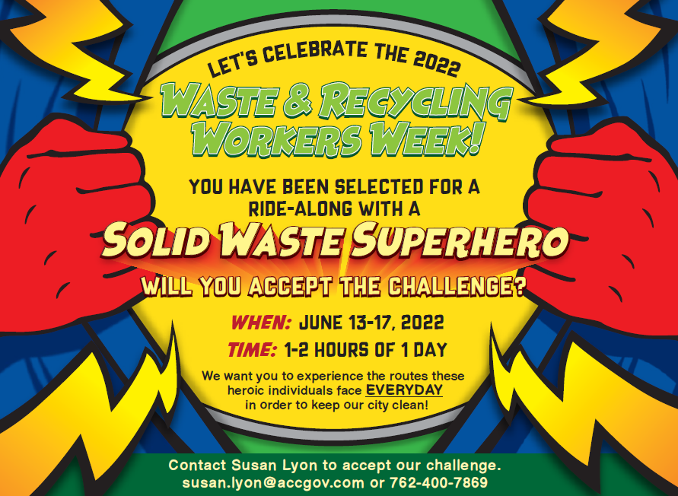
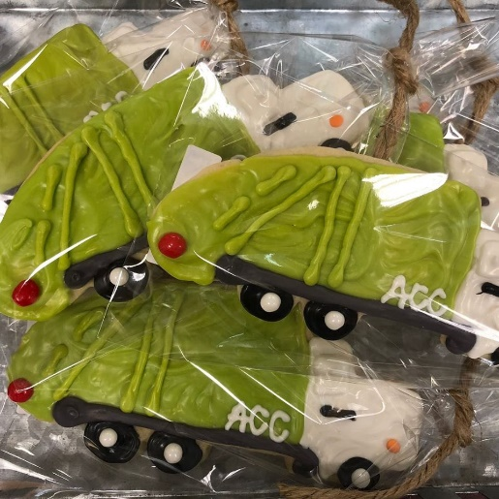

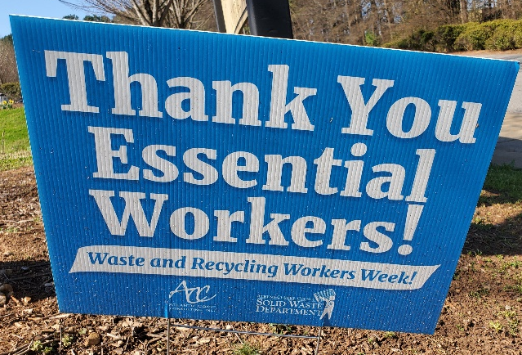
Athens-Clarke County Yard Signs used in 2021
Elected Official Invitation
Trash Truck Cookies

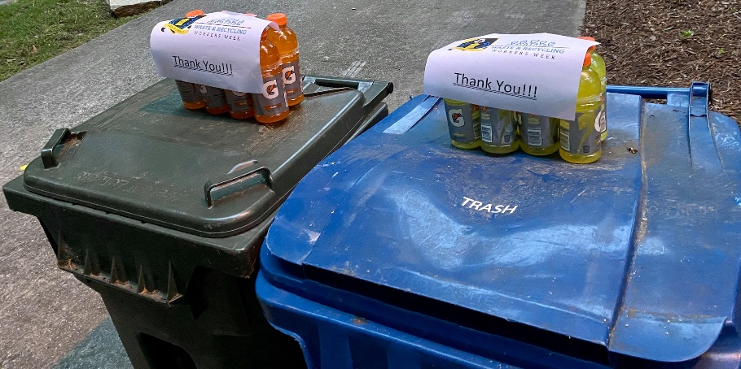
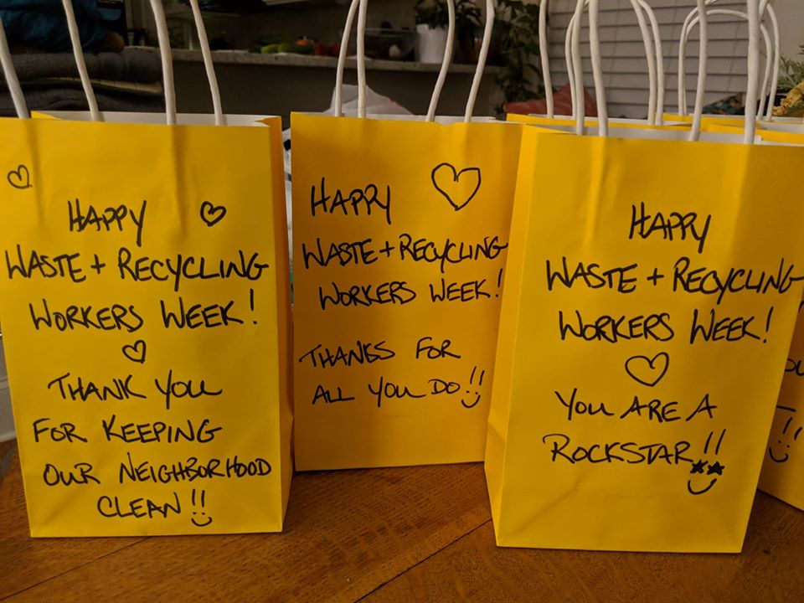
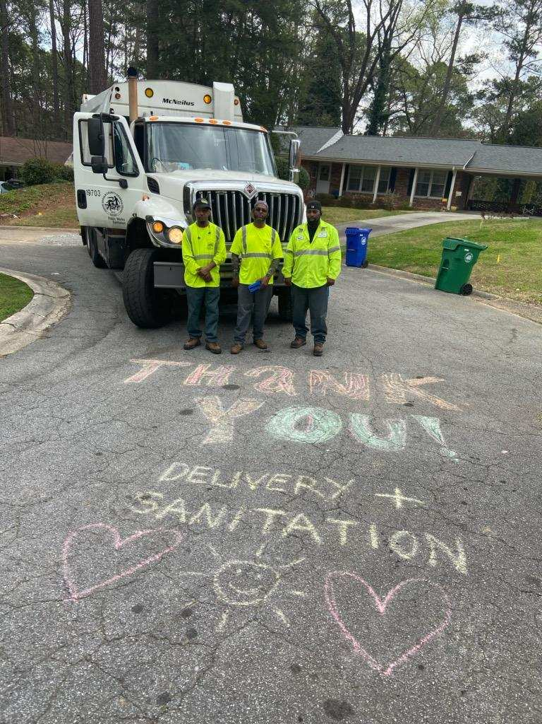
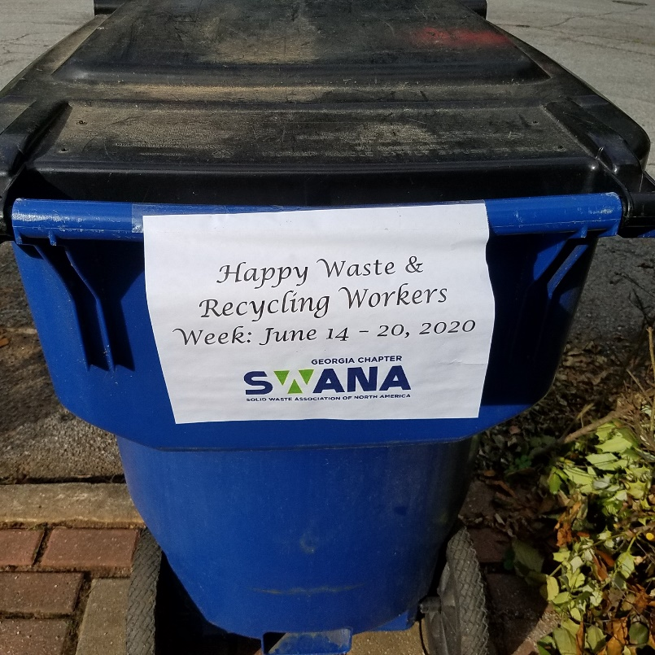
Examples of customers appreciating staff during W&RWW:

