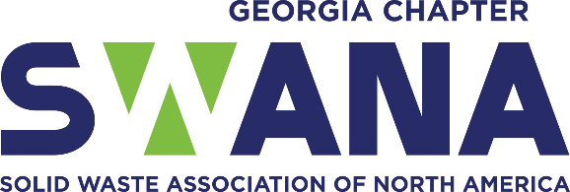
Social Media Content

Use on Facebook, Instagram or LinkedIn during Waste & Recycling Workers Week. Don’t forget the #ElevateSW2026 @SWANA-Georgia Chapter.
- We are Solid Waste Professionals #ElevateSW2026 2026@SWANA-Georgia Chapter

- I am a Solid Waste Professional #ElevateSW2026@SWANA-Georgia Chapter

- My job has value, and I am a Solid Waste Professional. #ElevateSW2026@SWANA-Georgia Chapter

- I collect your trash and am a Solid Waste Professional# ElevateSW2026@SWANA-Georgia Chapter

- I work at the landfill and am a Solid Waste Professional # ElevateSW2026@SWANA-Georgia Chapter

- I pick up litter and am a Solid Waste Professional #ElevateSW2026@SWANA-Georgia Chapter

- Celebrate Waste & Recycling Workers Week! #ElevateSW2026@SWANA-Georgia Chapter

- Did you know that waste and recyclable material collectors are in the top ten most dangerous jobs in the United States? We are currently 5th most dangerous job. Help keep us safe. #ElevateSW2026@SWANA-Georgia Chapter

- Picture or video of Mayor or Elected Official holding or reading the proclamation for Waste & Recycling Workers Week.

- Caption this? Find some fun photos of your sanitation/solid waste workers and ask your followers to add a caption.

- Complete the Solid Waste Superlatives for your staff and post the outcome on your social media pages. Make it fun!

- Catch solid waste employees in the act of servicing their community and post on your social media accounts.

- Find the SWANA Georgia Chapter Facebook and Instagram frame to use during the week and encourage followers to use the frame with worker photos.

- Record sanitation/solid waste workers in your community stating why they are a Solid Waste Professionals.

