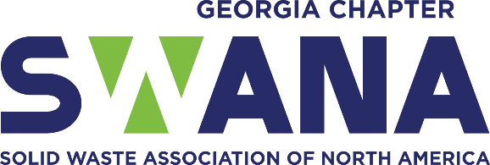
Sample Proclamation

WHEREAS: The state celebrates the Week of June 15- 20, 2026 as National Waste & Recycling Workers Week; and
WHEREAS: National Garbage Man Day began in 2012 to show community appreciation for the local people of the garbage, sanitation, and recycling industry and later changed the official name to Waste & Recycling Workers Week; and
WHEREAS: The earliest garbage regulation efforts began in 3000 B.C. when the first landfill was developed in Crete, where large holes were dug for refuse; and
WHEREAS: Since that time sanitation (solid waste) workers have worked selflessly and tirelessly in all types of environments (weather, pandemics, civil unrest, war) and at risk to themselves, to provide sanitation (solid waste) services to protect communities and residents, prevent disease, and keep our community clean, safe, and beautiful; and
WHEREAS: The people employed by (MUNICIPALITY/COMPANY/ORGANIZATION) make significant contributions to the safety, health, and welfare of our residents by processing millions of tons of garbage, recycling and composting annually; and
WHEREAS: With an area spanning (LOCAL GOVERNMENT/MUNICIPALITY SQUARE MILES) and many miles of roads, the residents of (LOCAL GOVERNMENT/MUNICIPALITY) depend on the collection and proper disposal of waste, recyclables, compostables and leaf and limb to promote a clean and tidy community regardless of weather and global pandemics; and
WHEREAS: The proper collection, disposal and maintenance of waste, recyclables, and compostables are vital to preventing disease and unsightly litter; and
WHEREAS: The sanitation (solid waste) industry is the 5th most dangerous job in the United States, and the people employed in this sector should be celebrated; and
WHEREAS: The sanitation (solid waste) industry employs thousands of people around the United States, and they should be elevated because they provide necessary services to the communities they serve; and
WHEREAS: (LOCAL GOVERNMENT) values and celebrates our local (SANITATION OR SOLID WASTE) industry workers for their commitment to our residents, businesses and communities and we want to ELEVATE (Sanitation or Solid Waste) History, Individuals and the Profession as a whole.
NOW, THEREFORE, I, (ELECTED OFFICIAL/MAYOR), by virtue of the authority vested in me as (TITLE OF ELECTED OFFICIAL/MAYOR) of the (LOCAL GOVERNMENT), Georgia, do hereby proclaim June 15-20, 2026 as Waste & Recycling Workers Week in (LOCAL GOVERNMENT) and encourage all residents to join me in thanking the hardworking men and women who ensure our communities are kept save, clean and healthy.

